Notice to Businesses

The Town of Rocky Harbour has, for the past several years, provided Town/Business Maps to local businesses free of charge.
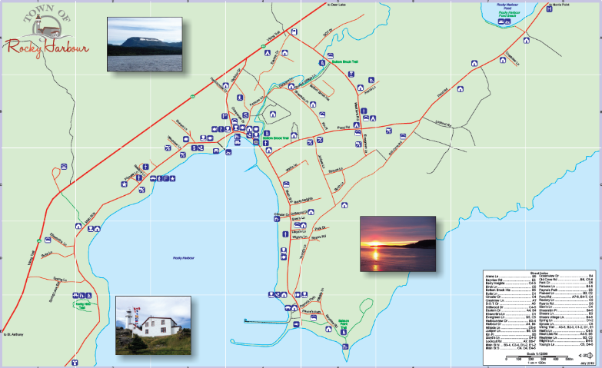

Beginning this year, a cost of $10/100 page booklet will be charged to help offset current printing fees.

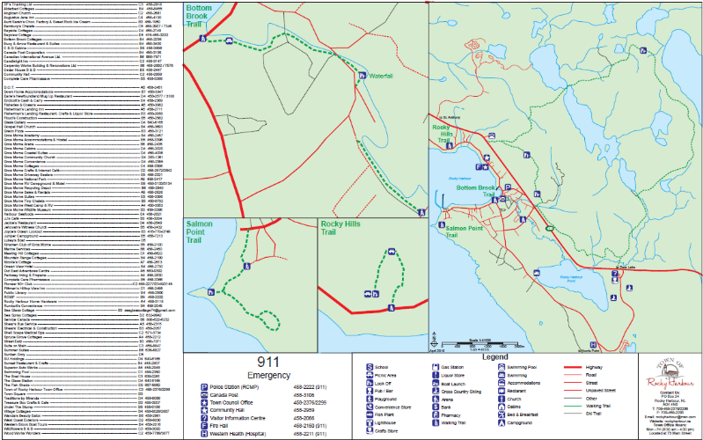
We regret that this cost must be passed on but, the times, they are a’ changing!

-Town of Rocky Harbour

